Capstone Project: The Battle of Neighborhoods

What are the common features of areas with high COVID case rate in New York?

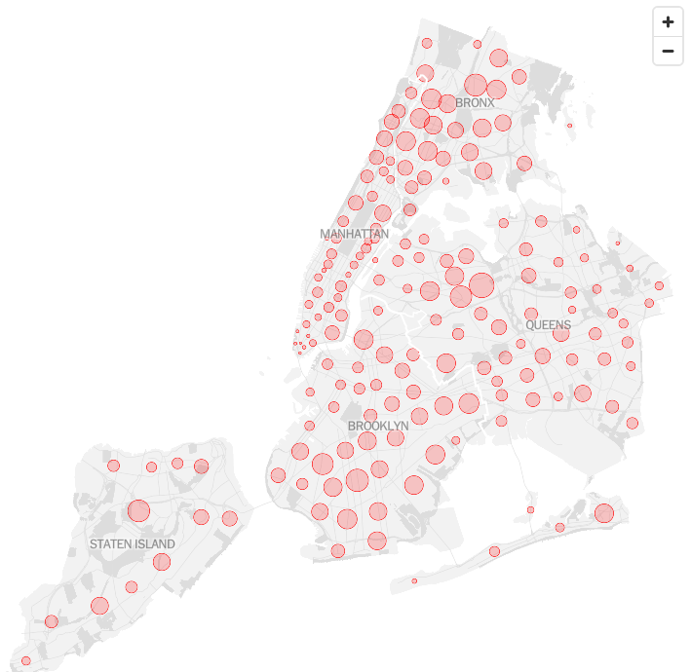

**Introduction**

On March 11, 2020, the World Health Organization declared that COVID-19 was a global pandemic, indicating a significant global spread of an infectious disease [1]. At that point, there were 118,000 confirmed cases of the coronavirus in 110 countries [2]. China was the first country to report the spread of this new disease with an outbreak in January 2020. South Korea, Iran, and Italy followed in February with their own outbreaks. Weeks later, the virus was in all continents and over 177 countries. Unfortunately, the United States has the highest number of confirmed cases and, sadly, the most deaths. The virus was extremely contagious and led to death in the most vulnerable, particularly those older than 60 and those with underlying conditions. A lot of cities suffered from overwhelming local health care systems.

As the deaths rose from the virus that had no effective treatment or vaccine, countries shut their borders, banned travel to other countries, and began to issue orders for their citizens to stay at home. Schools and universities closed their physical locations and moved education online. Sporting events were canceled, airlines cut flights, tourism evaporated, restaurants, movie theaters and bars closed, theater productions canceled, manufacturing facilities, services, and retail stores closed. In some businesses and industries, employees have been able to work remotely, but in others, workers have been laid off, furloughed, or had their hours cut. However, the virus didn't disappear like a miracle during the summer. And the situation bounced back in this fall and winter. This long-lasting situation has largely changed people's daily lives.

In this capstone project, I did a tiny study to explore the distribution of COVID cases in New York and tried to understand what were the common features of those neighborhoods with relatively high COVID confirmed cases. With the venues data collected from Foursquare, neighborhoods in New York were clustered into 5 groups. The results showed that 70% of the top 20 areas with the highest confirmed case rate were from the same group. And most venues in these areas with the highest amounts were in food-related categories, such as Pizza Place, Deli/Bodega, Restaurant, Bagel Shop, Ice Cream Shop, Grocery Store, Bakery, and Coffee Shop. The result suggests that we need to take extra caution when we have to visit these kinds of places during the pandemic.

This pandemic has demonstrated the interconnected nature of our world and that no one is safe until everyone is safe. Only by acting in solidarity can communities save lives and overcome the devastating impacts of the virus. I hope this little finding in this study can serve as a caution for everyone, helping them protect themselves, protect their families, and protect people around them.

**Data**

**COVID data**

The COVID case data of New York come from NYC Health [3,4]. The data contains cumulative totals since the start of the COVID-19 outbreak in New York City, which the Health Department defines as the diagnosis of the first confirmed COVID-19 case on February 29, 2020 [4]. The data used in this study were grouped by Modified Zip Code Tabulation Areas (MODIFIED_ZCTA).

The geography information is reported using MODIFIED_ZCTA because it can be challenging to map data that are reported by ZIP Code. A ZIP Code doesn’t actually refer to an area, but rather a collection of points that make up a mail delivery route. Furthermore, there are some buildings that have their own ZIP Code, and some non-residential areas with ZIP Codes. To deal with the challenges of ZIP Codes, the Health Department uses ZCTAs which solidify ZIP codes into units of area. Often, data reported by ZIP code are actually mapped by ZCTA. The ZCTA geography was developed by the U.S. Census Bureau. The modified ZCTA geography combines census blocks with smaller populations to allow more stable estimates of population size for rate calculation.

In this dataset, one MODIFIED_ZCTA may contains one or more neighborhoods. And in some cases, one neighborhood is also separated into two or more MODIFIED_ZCTAs. Since this will not influence my search for features in areas with high COVID rate, I will perform the analysis using MODIFIED_ZCTA instead of neighborhood.

The data contain both number of confirmed cases by MODIFIED_ZCTA (COVID_CASE_COUNT) and rate of confirmed cases per 100,000 people by MODIFIED_ZCTA (COVID_CASE_RATE). To minimize the influence of different populations in different area, I only use COVID_CASE_RATE for my study.

The COVID data are updated daily. The data used in this study are based on the version of 12/16/2020.

**Geographical coordinate**

The latitude and longitude for each MODIFIED_ZCTA are collected from GeoPy using geocoders.nominatim. These geographical coordinates will be used to search for venues in each area.

**Venue data**

Venue data are collected from Foursquare. Due to the limitation of requests that can be made, I only collect 100 venues for each MODIFIED_ZCTA with a radius of 1000m. The constraint here may have influence the final result. But it is still possible to obtain some preliminary understandings from the venue data. The venue data will be used to clustered different areas of New York City into groups. And areas with cluster labels will be compared with COVID rates in order to find out whether areas with high COVID rates have common features.

**Methodology**

**Retrieving and processing COVID data**

The COVID case data of New York City are retrieved from NYC Health. The dataframe contains 10 columns, including MODIFIED_ZCTA, neighborhood name, total case count, and case rate. And it contains case counts for 177 areas. Here are the first 10 rows of the dataframe, showing parts of the columns.

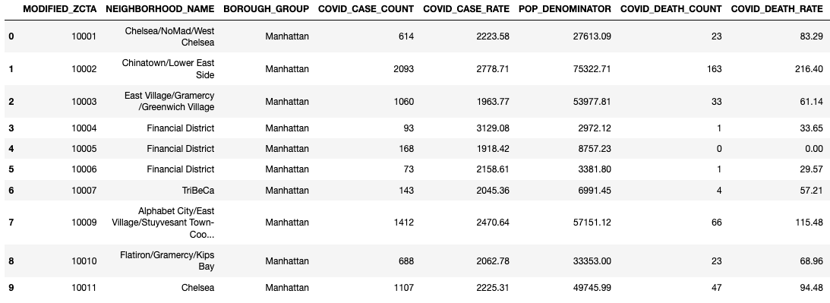

Some areas include two or more neighborhoods. For example, 10001 contains 3 neighborhoods, Chelsea, NoMad, and West Chelsea. In some other cases, one neighborhood can be divided into several MODIFIED_ZCTA. For example, Financial District are separated into 10003, 10004, and 10005; while both 10001 and 10011 show Chelsea. Since there is no way to attribute the COVID case count into each neighborhood and I only need to focus on the common features, I will treat these neighborhoods together as one single area to simplify the process. And we will continue the following analysis based on MODIFIED_ZCTA.

Since different MODIFIED_ZCTAs have different populations, using actual COVID case counts will bias the result. To exclude the influence of population in each area, the following analysis will use COVID_CASE_RATEs instead, which represent rate of confirmed cases per 100,000 people by MODIFIED_ZCTA.

**Combining geographical coordinates**

In order to collect features for each area, geographical coordinates are first retrieved for each MODIFIED_ZCTA using GeoPy. Now, the data of interest look like this (showing first 5 rows only).

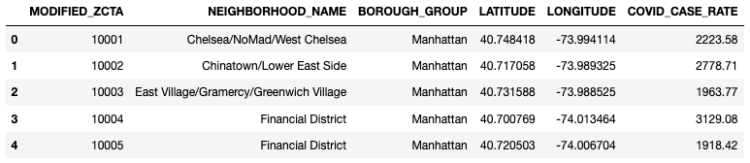

**Visualization of COVID data**

With the latitudes and longitudes of all areas, we can get a basic understanding of the distribution of COVID cases by creating a map of New York with overlapping bubbles. The sizes of the circles represent the relative case rates of the areas.

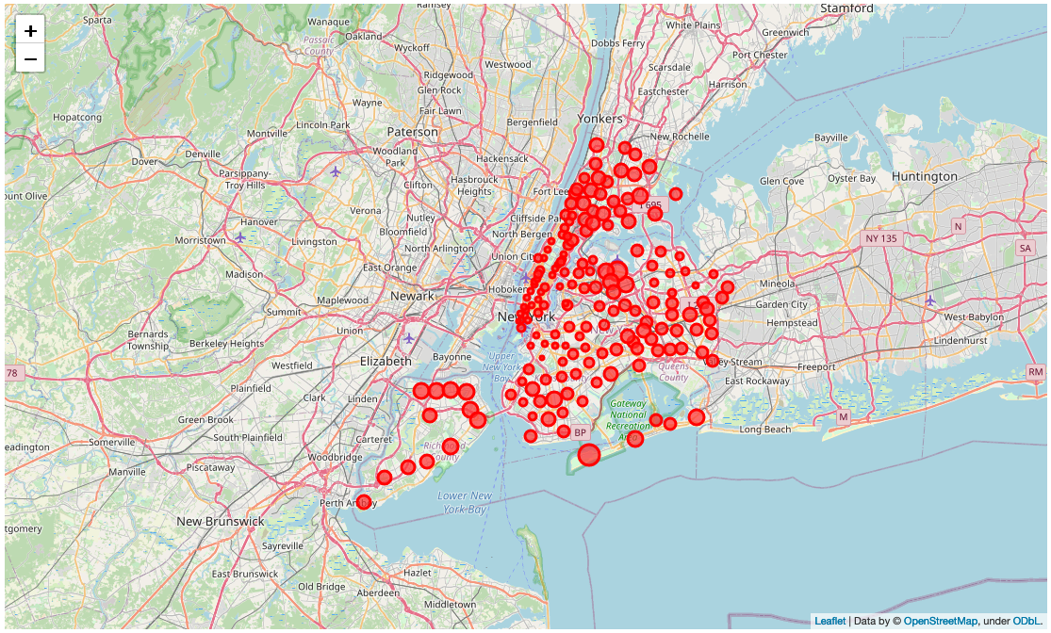

**Collecting venue information**

To cluster these 177 neighborhoods, venue information is collected for each MODIFIED_ZCTA from Foursquare. However, we only collect 100 venues for each area due to the limitation, and we set the radius to 1000m.

A total number of 13589 venues for these 177 areas are collected, with their names and categories listed. Here is an example of the first few venues.

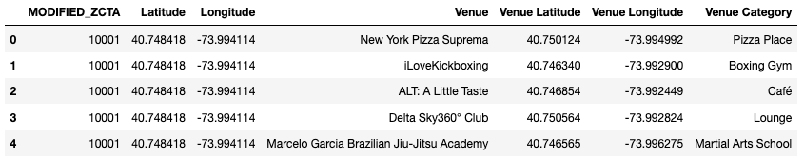

And there are 444 unique categories curated from all the returned venues. One hot encoding is used to represent the results. And data are further grouped by MODIFIED_ZCTA and by taking the mean of the frequency of occurrence of each category. In this way, we can easily sort our data and figure out the most common or popular venues in each area. Here is an example showing the top 10 most common venues for each area. These venues will serve as features of areas and will be used to cluster these areas.

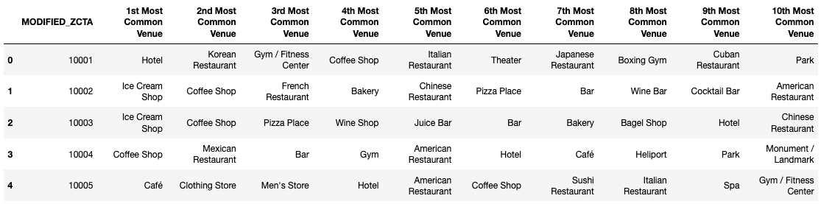

**Clustering neighborhoods**

Using the venue information collected above, we will cluster these 177 areas into several groups. In this study, the k-means method is applied. So, we need to find out the most suitable number of clusters, k. Here, we are using the elbow method.

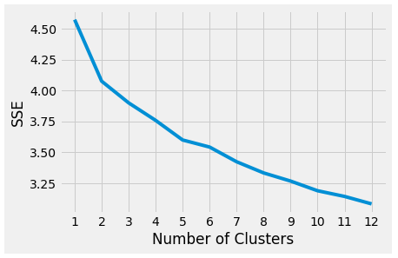

From the number of cluster vs. the sum of the squared distance between centroid and each member of the cluster (SSE), we can find that there are 2 obvious turns. Using only 2 clusters in this study is not enough, so I will use k = 5.

With a suitable number of clusters, we further apply the clustering to our data and add the cluster labels to our previous dataframe (only a small part of the dataframe is shown).

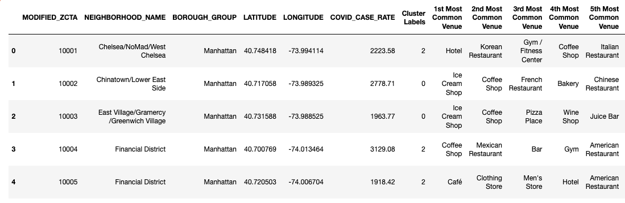

With the clustering result, we can generate a map of New York City with these labels again.

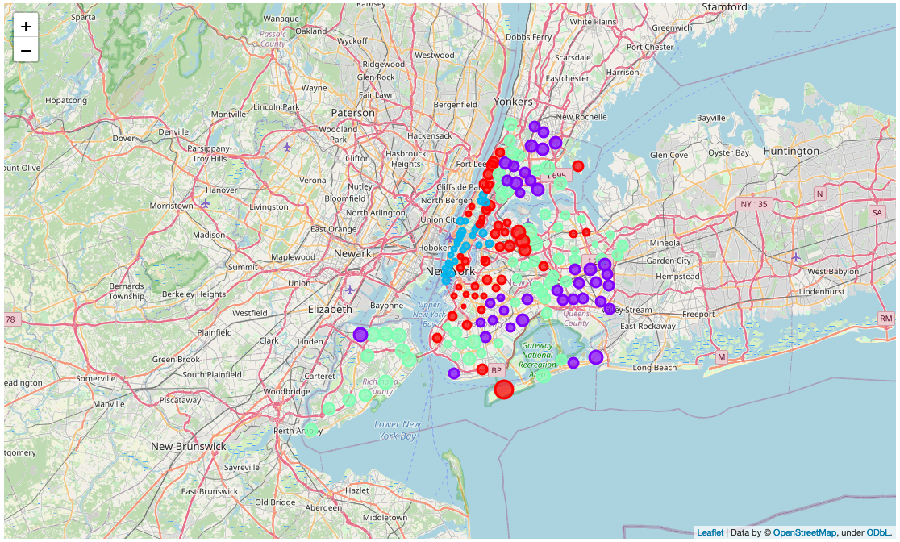

**Results and discussions**

If we select the top 20 areas with the highest COVID case rate, we can find that 70% of them are labeled as cluster 3, which means those areas suffered from high COVID case rates do share some common features. Cluster 3 is shown as green circle in the map above.

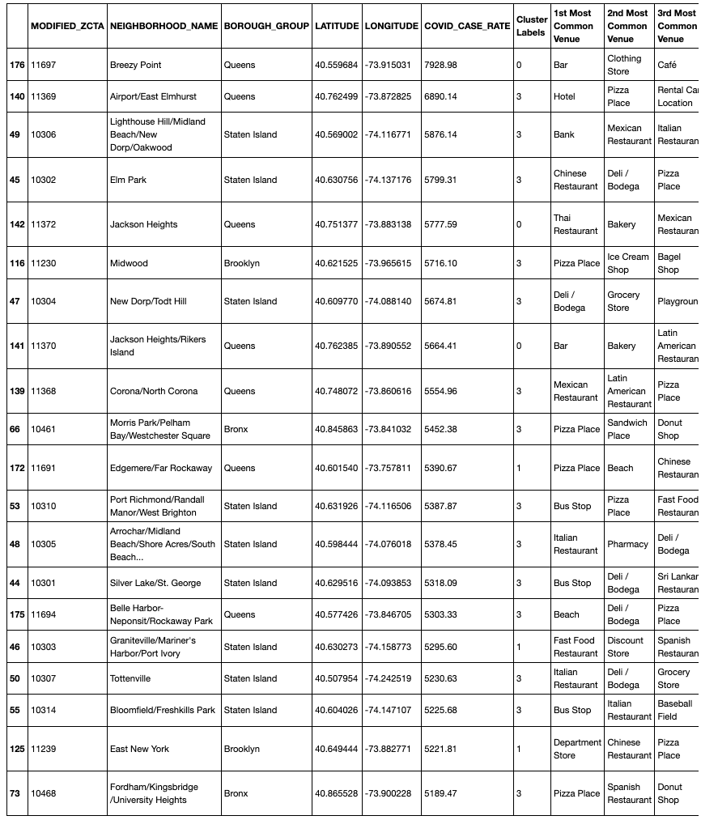

Now, let's further exam the venues of these 14 areas labeled as cluster 3 in the top20 list. And all these 140 categories will be weighted and merged together into one dataframe. In this way, we can find out the most common venues in the high COVID case rate areas.

Among these 14 areas, there are 60 unique venue categories. The top 20 most common categories are shown below:

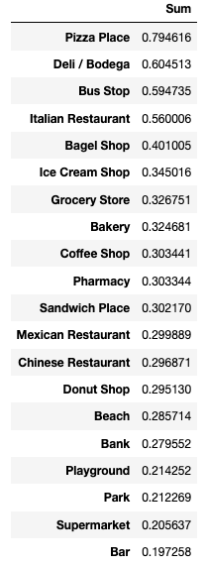

After summing up all the relative numbers of each categories, we can find out the top 20 most common categories in the high COVID case rate areas. The result shows that 70% of these popular venues are related to food. And here is bar plot to better show the relative amount of these venues.

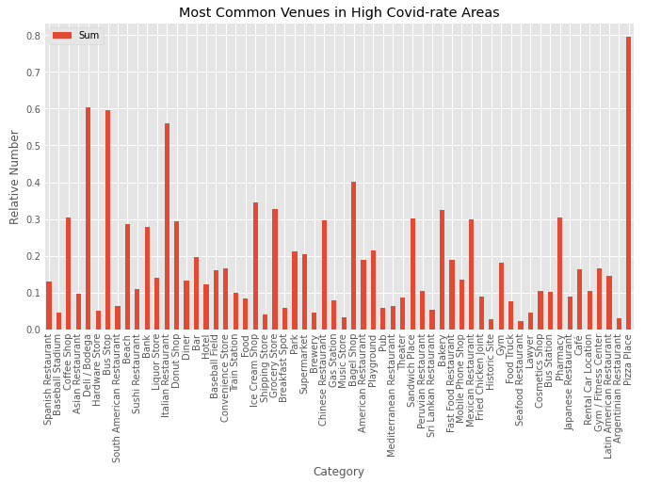

It clearly shows that Pizza Place, Deli/Bodega, Bus Stop, and Italian Restaurant have much larger relative amount than other categories in these areas. The result implies that these 4 categories may have positive relationship with COVID case rates.

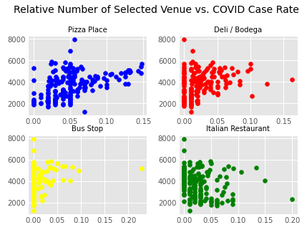

If we apply this guess to all 177 MODIFIED_ZCTAs, we can generate the scatter plots above. The x-axis represents the relative number of selected categories in each area, while the y-axis is the COVID case rate. It seems that there is a strong positive relationship between Pizza Place and COVID case rate. Deli/Bodega also shows a weaker relationship, while there is basically no relationship between Bus Stop or Italian Restaurant and case rate. This is probably because these two categories are selected from cluster label 3, and Bus Stop or Italian Restaurant are not features or common categories in other clusters.

**Conclusions**

From this preliminary study, we notice that most of the MODIFIED_ZCTAs with high COVID case rates are clustered into same groups (Cluster 3), implying that they share similar features. Closer examination of 14 areas labeled with cluster 3 in the top 20 highest COVID-case-rate areas shows that food related categories are quite common. 70% of the top 20 most common venues in these 14 areas are in food-related categories, such as Pizza Place, Deli/Bodega, Restaurant, Bagel Shop, Ice Cream Shop, Grocery Store, Bakery, and Coffee Shop. The result suggests that we need to take extra caution when we have to visit these kinds of places during the pandemic. Although this study is quite limited by the data, I still hope this little finding can serve as a caution for everyone, helping people to protect themselves, protect their families, and protect people around them from the virus.

**References**

[1] https://www.who.int/emergencies/diseases/novel-coronavirus-2019

[2] https://www.ncbi.nlm.nih.gov/pmc/articles/PMC7205668/

[3] https://www1.nyc.gov/site/doh/covid/covid-19-data.page

[4] https://github.com/nychealth/coronavirus-data